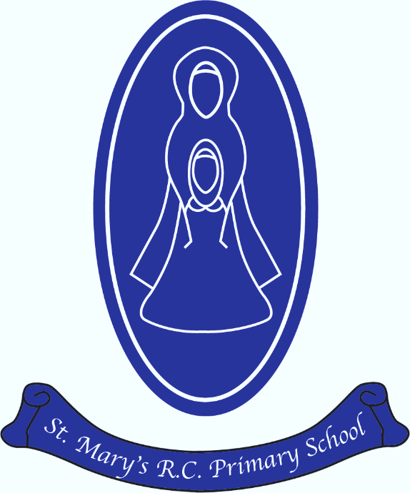
St Mary’s R.C Primary

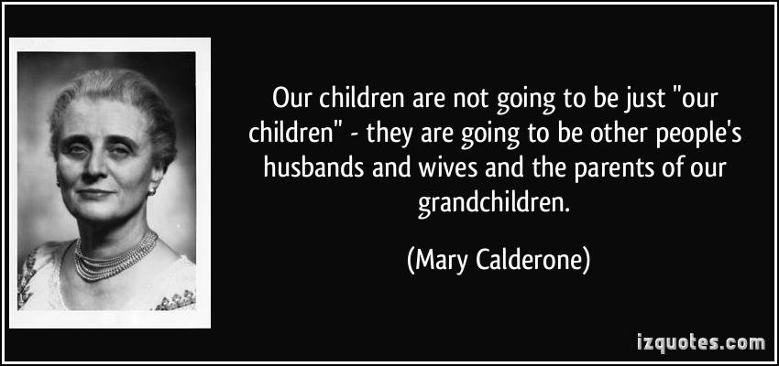
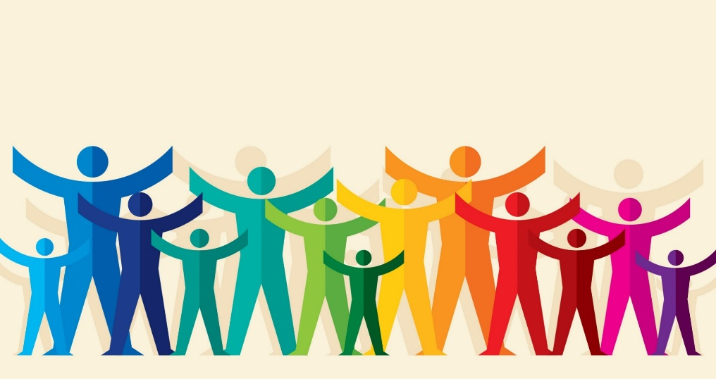
PSHE progression and end points curriculum map
PSHE Progression of skills
St Mary’s RC Primary School
Year group | Relationships | Health and wellbeing | Living in the wider world
EYFS | - Family - about the different people in their family / those that love and care for them and the difference in families.  - Key people they can talk to about their worries. | - Physical health and what keeps us healthy. | - Kind and unkind behaviour  - Their roles in a classroom  - how to manage change when moving to a new class/year group
Year 1 | - Likes and dislikes  - What makes them special  - Similarities and differences  - Correct names for body parts (including genitalia)  - Families and differences in families | - What being healthy means on a daily basis and over time  - Healthy eating  - Importance of hygiene  - Who can help in different places and in different situations.  - Stanger danger  - What to do if they feel unsafe or worried  - How to get help if they need it, including 999 calls. | - Kind and unkind behaviours and how they affect others  - Responsibilities they have in and out of classroom.  - Growing and changing  - Community and their roles in it  - How people and animals need to be cared for
Year 2 | - Making and maintaining friendships  - Feeling lonely and how to respond to this  - Resolving arguments  - Permission around their bodies  - why name-calling, hurtful teasing, bulling and deliberately excluding others is unacceptable | - How rules and restrictions help them to keep safe  - How to identify unsafe and risky situations  - Online safety  - What can keep their bodies healthy  - What can affect their health negatively  - Different ways to play  - Name and recognise a range of feelings  - How to manage big feelings | - Look at jobs and earning money  - Different strengths and interests lead to different jobs.
Year 3 | - How friendships support wellbeing  - How to support others feeling lonely or excluded  - Building goof friendships | - How to recognise hazards and reduce risks  - How to keep their bodies protected and safe in different situations  - Their body belongs to them  - how to react and respond if there is an accident and how to deal with minor injuries  - how to eat a healthy diet and the benefits of nutritionally rich foods  - how to maintain good oral hygiene  - Healthy lifestyles | - Belonging to different groups and communities.  - Being respectful to those with differing lifestyles
Year 4 | - How behaviour affects others including online  - Rights and responsibilities in relationships  - The right to privacy  - The rights that children have and how to protect these  - that everyone should feel included, respected and not discriminated against; how to respond if they witness or experience exclusion, disrespect or discrimination  - how to respond to aggressive or inappropriate behaviour (including online and unwanted physical contact) – how to report concerns | - Developing self-worth  - How to manage when there are set backs and learn from mistakes  - Feelings and the importance of expressing feelings and how feelings can change  - How to access advice and support  - About puberty  - How to keep safe in the wider environment  - Online safety  - Reporting concerns (including online) | - How people have a shared responsibility for the world around them  - Money (buying and spending) and how this can affect others  - How to show care for others
Year 5 | - Different relationships  - Communicating with friends and family online and how this can be positive  - Online friendships compared to face to face  - Sharing content online  - Giving consent  - Online safety | - Respecting similarities and differences  - What makes up a persons identity  - About stereotypes  - Basic first aid  - Emergency situations  - Puberty and changes | - Spending and saving  - Risks associated with money  - Jobs and their qualifications  - How they might decide on a career  - How to challenge stereotypes around jobs
Year 6 | - that people who are attracted to and love each other can be of any gender, ethnicity or faith; the way couples care for one another  - that adults can choose to be part of a committed relationship or not  - Puberty relating from childhood to adulthood  - Friendships changing as they grow  - How to manage change as they move to secondary school | - how mental and physical health are linked  - How being part of groups can support their wellbeing  - how to make choices that support a healthy, balanced lifestyle  - how legal and illegal drugs (legal and illegal) can affect health and how to manage situations involving them  - how to recognise early signs of physical or mental ill-health and what to do about this, including whom to speak to in and outside school | - how the media, including online experiences, can affect people’s wellbeing – their thoughts, feelings and actions  - to evaluate how reliable different types of online content and media are, e.g. videos, blogs, news, reviews, adverts  - to discuss and debate what influences people’s decisions, taking into consideration different viewpoints

