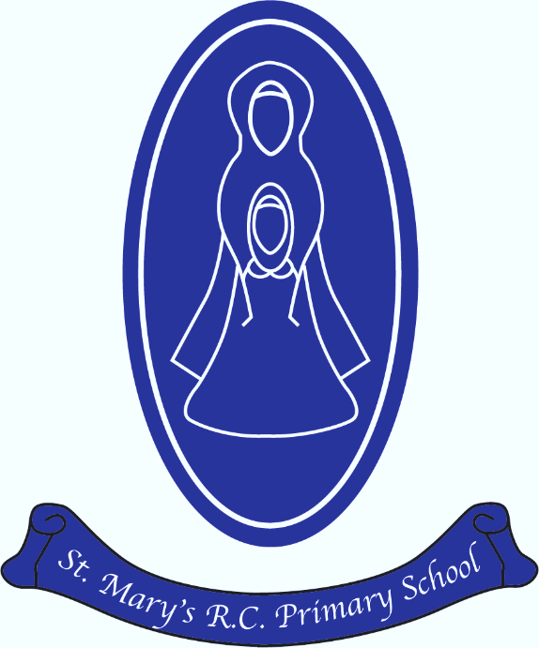
St Mary’s R.C. Primary
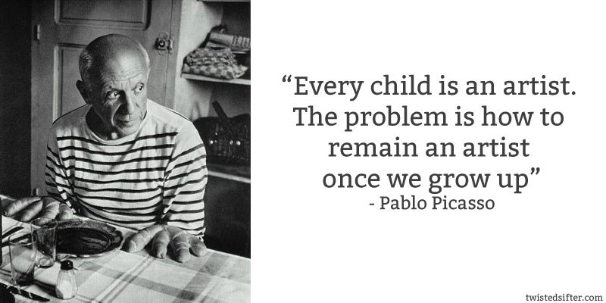

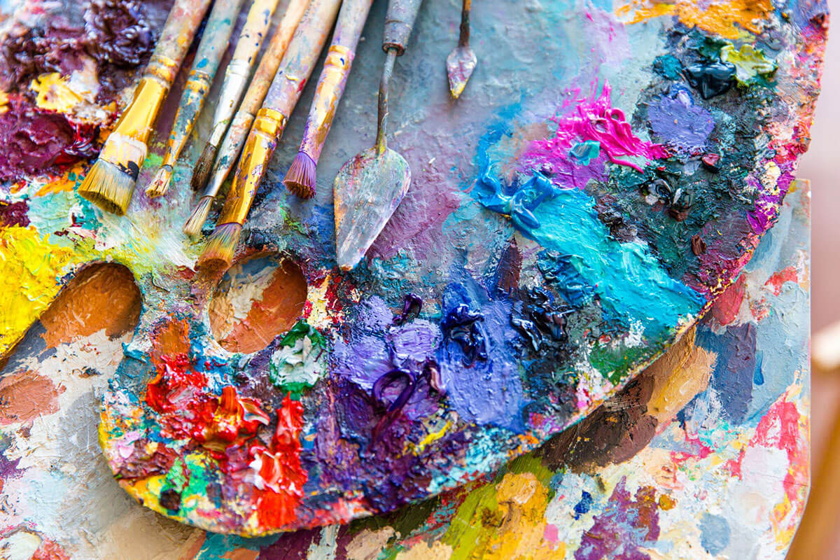
Art & Design Annual Curriculum Map
St Mary’s R.C. Primary
Art & Design Annual Curriculum Map

Art & Design Curriculum Map – Autumn Term
Term | Nursery | Reception | Year 1 | Year 2 | Year 3 | Year 4 | Year 5 | Year 6
Autumn 1 | Drawing / painting skills – self portraits | Drawing / painting skills – self portraits  Mixing paints | Drawing  Self portraits  Artist - Picasso | Paint, Textiles, digital media  Artist - Monet | College, sculpture, drawing, print  Artist—Picasso | Sculpture , drawing  Artist - Gaudi | Paint, sculpture, textiles, digital media,  Artist – Ciruelo Cabral/ Michael Komark | Paint, drawing, textiles  Artist – John Dyer
Autumn 2 | Scissor skills / collage | Scissor skills /  Printing / clay  Artist - Kandinsky |  |  |  |  |  | Paint, drawing, textiles  Artist – William Morris
Art & Design Curriculum Map – Spring Term
Spring 1 | Printing / collage / manipulating dough | Scissor skills /  Chinese art / printing/ | Print, collage and sculpture  Artist – Paul Klee | Collage, Drawing  Artist - Lowry | Paint, Collage, Drawing, Print Textiles | Paint, Collage, Print | Paint, print, textiles  Artist – Hans Holbein | Sculpture, drawing  Artist – Jackson Pollok
Spring 2 | Drawing /scissor skills / paint mixing | Colour mixing / collage / drawing |  |  |  |  |  | Sculpture, drawing  Artist – Stephen Wiltshire
Art & Design Curriculum Map - Summer Term
Summer 1 | Drawing / paint  Artist - Van Gogh | Drawing / collage / clay /  Artist - Van Gogh | Paint, textiles, Digital Media  Artist—Andy Goldsworthy | Sculpture, Print  Artists - Georgina O’Keeffe, William Morris and Van Gogh | Drawing, print, textiles  Artist—Aaron Becker | Textiles / digital media  Artist - Henri Rousseau/Paul Gauguin | Paint, collage, sculpture, drawing  Artist – Henri Rousseau / Clifford Possum | Collage, print, textiles, digital media  Artist – Andy Warhol
Summer 2 | Printing / scissor skills / collage | Printing / paint / collage  Artist - Andy Warhol |  |  | Drawing, print, textiles  Artist—Rembrandt

