St Mary’s R.C Primary
Art & Design Progression Map and End Points

St Mary’s R.C. Primary
Art Curriculum Progression and End Points

End of EYFS |  | End of KS1 | End of Lower KS2 | End of Upper KS2
To develop ideas | - Create collaboratively  - Share ideas, resources and skills.  - Explore, use and refine a variety of artistic effects to express their ideas and feelings  - Pupils can safely use and explore a variety of materials, tools and techniques, experimenting with colour, design, texture, form and function.  - Pupils can share their creations, explaining the process they have used.  - Pupils can make use of props & materials when role playing characters in narratives & stories. | - Respond to ideas and starting points.  - Explore ideas and collect visual information.  - Explore different methods and materials as ideas develop. | - Develop ideas from starting points throughout the curriculum.  - Collect information, sketches and resources.  - Adapt and refine ideas as they progress.  - Explore ideas in a variety of ways.  - Comment on artworks using visual language. | - Develop and imaginatively extend ideas from starting points throughout the curriculum.  - Collect information, sketches and resources and present ideas imaginatively in a sketchbook.  - Use the qualities of materials to enhance ideas.  - Spot the potential in unexpected results as work progresses.  - Comment on artworks with a fluent grasp of visual language.
To master techniques | Painting  - Continue to explore colour and colour mixing using appropriate techniques.  - To know the primary colours and that mixing these will create a new colour  - Explore using different tools for painting  Sculpture  - To know how to join materials to create a model and use material to finish the design  - To know how to mould different resources to make a sculpture e.g. clay  - Use techniques such as paper folding, rolling and cutting  Drawing  - To know a pencil can create different lines  - To draw with increasing complexity and detail  - To explore coloured pencils for different effects  Print  - Explore the use of repeating or overlapping shapes.  - Use print from the environment (e.g. wrapping paper) as a stimulus  - Explore using objects to create prints  - Explore techniques to make prints e.g. rub and stamp | Painting  - Use thick and thin brushes.  - Mix primary colours to make secondary.  - Add white to colours to make tints and black to colours to make tones.  - Create colour wheels.  Sculpture  - Use a combination of shapes.  - Include lines and texture.  - Use rolled up paper, straws, paper, card and clay as materials.  - Use techniques such as rolling, cutting, moulding and carving.  Drawing  - Draw lines of different sizes and thickness.  - Colour (own work) neatly following the lines.  - Show pattern and texture by adding dots and lines.  - Show different tones by using coloured pencils.  Print  - Use repeating or overlapping shapes.  - Mimic print from the environment (e.g. wallpapers).  - Use objects to create prints (e.g. fruit, vegetables or sponges).  - Press, roll, rub and stamp to make prints.  Collage  - Use a combination of materials that are cut, torn and glued  - Sort and arrange materials  - Use a combination of materials that are cut, torn and glued  - Mix materials to create texture  - Sort and arrange materials  Textiles  - Use weaving to create a pattern  - Use plaiting  - Join materials using glue and/or a stitch  - Use dip dye techniques  Digital Media  - Use a wide range of tools to create different textures, lines, tones and colours and shapes | Painting  - Use a number of brush techniques using thick and thin brushes to produce shapes, textures, patterns and lines.  - Mix colours effectively.  - Use watercolour paint to produce washes for backgrounds then add detail.  - Experiment with creating mood with colour.  Sculpture  - Create and combine shapes to create recognisable forms (e.g. shapes made from nets or solid materials).  - Include texture that conveys feelings, expression or movement.  - Use clay and other mouldable materials.  - Add materials to provide interesting detail.  Drawing  - Use different hardnesses of pencils to show line, tone and texture.  - Annotate sketches to explain and elaborate ideas.  - Sketch lightly (no need to use a rubber to correct mistakes).  - Use shading to show light and shadow.  - Use hatching and cross hatching to show tone and texture.  Print  - Use layers of two or more colours.  - Replicate patterns observed in natural or built environments.  - Make printing blocks (e.g. from coiled string glued to a block).  - Make precise repeating patterns.  Collage  - Select and arrange materials for a striking effect  - Use coiling, overlapping, tessellation, mosaic and montage  - Ensure work in precise  - Use coiling, overlapping, tessellation, mosaic and montage  Textiles  - Shape and stitch materials  - Colour fabric  - Create weavings  - Use basic cross stitch and back stitch  - Quilt, pad and gather fabric  Digital Media  - Create images, video and sound recordings and explain why they were created | Painting  - Sketch (lightly) before painting to combine line and colour.  - Create a colour palette based upon colours observed in the natural or built world.  - Use the qualities of watercolour and acrylic paints to create visually interesting pieces.  - Combine colours, tones and tints to enhance the mood of a piece.  - Use brush techniques and the qualities of paint to create texture.  - Develop a personal style of painting, drawing upon ideas from other artists.  Sculpture  - Show life-like qualities and real-life proportions or, if more abstract, provoke different interpretations.  - Use tools to carve and add shapes, texture and pattern.  - Combine visual and tactile qualities.  - Use frameworks (such as wire or moulds) to provide stability and form.  Drawing  - Use a variety of techniques to add interesting effects (e.g. reflections, shadows, direction of sunlight).  - Use a choice of techniques to depict movement, perspective, shadows and reflection.  - Choose a style of drawing suitable for the work (e.g. realistic or impressionistic).  - Use lines to represent movement.  Print  - Build up layers of colours.  - Create an accurate pattern, showing fine detail.  - Use a range of visual elements to reflect the purpose of the work.  Collage  - Mix textures (rough and smooth, plain ad patterned)  - Combine visual and tactile quantities  - Use ceramic mosaic materials and techniques  Textiles  - Show precision in techniques  - Combine previously learned techniques to create pieces  - Choose a range of stitching techniques
To take inspiration from the greats (classic and modern) | - Explore the work of some famous artists e.g. Van Gogh and use these pictures as a stimulus | - Describe the work of notable artists, artisans and designers.  - Use some of the ideas of artists studied to create pieces. | - Replicate some of the techniques used by notable artists, artisans and designers.  - Create original pieces that are influenced by studies of others. | - Give details (including own sketches) about the style of some notable artists, artisans and designers.  - Show how the work of those studied was influential in both society and to other artists.  - Create original pieces that show a range of influences and styles.

St Mary’s RC Primary
Art Curriculum Progression and End Points

Year 1 | Year 2 | Year 3
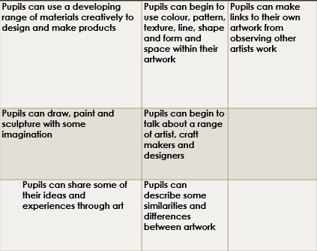 | 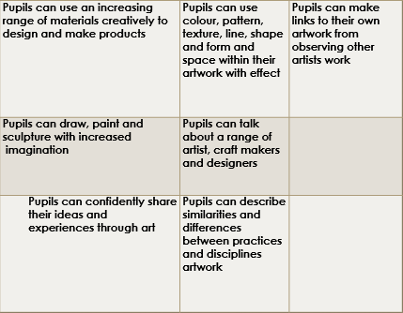 | 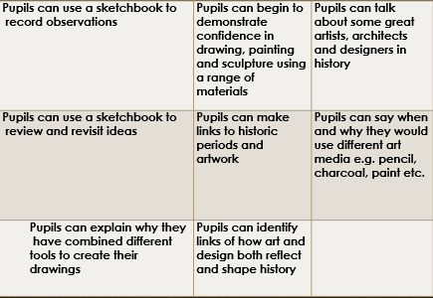
Year 4 | Year 5 | Year 6
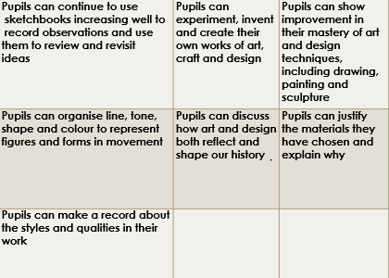 | 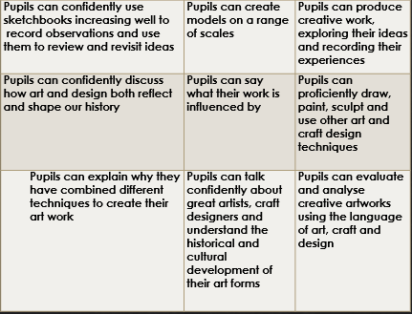 | 