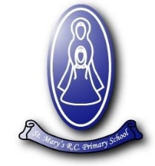

St Mary’s RC Primary School
General Data Protection Regulation (GDPR)

Dear Parents,
Our school complies with the General Data Protection Regulations which came into force in May 2018.
The aim of the regulations is to make personal information even more confidential than it already is under the current Data Protection act.
In the UK the Information Commissioners Office will check that everyone is complying with the law.
We take your privacy seriously. We will include aspects of the GDPR in the IT and computing curriculum so that your children learn how to protect their privacy and online reputation in our highly technological world.
The school staff have had the training so that they are familiar with the requirements of the GDPR. Our documentation is GDPR compliant. Families will see letters requesting consent for some school activities, such as for the use of photographs. Please note that we have to have a reply to these letters, otherwise your child might miss out when you would actually prefer them to be included: we cannot just assume that you agree (or don’t agree)!
We regularly review the security of all our IT systems and the storage of our paper records. If any companies or partner agencies have access to any school data then we require them to confirm that they also comply with GDPR.
There is a GDPR section on our website that contains privacy notices for children, families and staff. There is also a template of the acceptable use policy we will ask all KS2 children to sign with parental consent.

