St Mary’s R.C. Primary

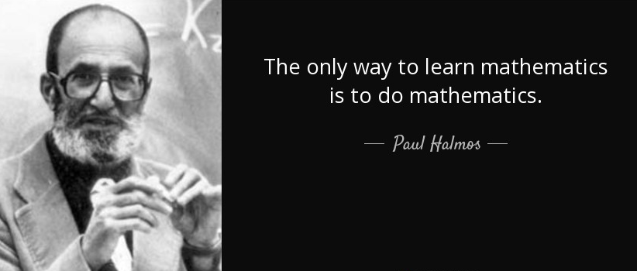
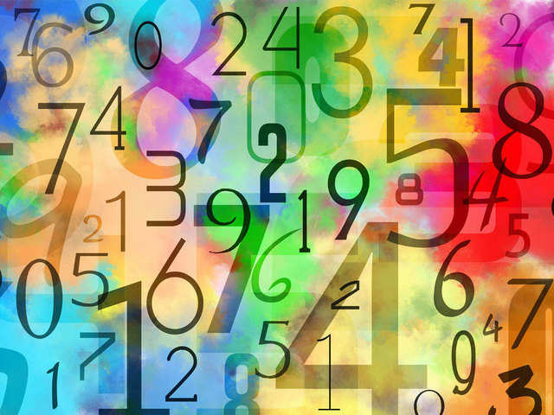
Mathematics Annual Curriculum Map

Term | Year 1 | Year 2 | Year 3 | Year 4 | Year 5 | Year 6
Autumn | Unit 1: Numbers Place Value  + - 1 within 20 | Unit 1: Place Value  10s and 1s  Partitioning | Unit 1: Place value within 1000 | Unit 1: Place value 4-digit numbers  Negative Numbers | Unit 1: Place value within 1,000,000 | Unit 1: Place value within 10,000,000
 |  | Unit 2: Estimating | Unit 2: Addition & subtraction | Unit 2: Addition and Subtraction  Include measures  Include perimeter | Unit 2: Addition & subtraction  Include measures  Include perimeter | Unit 2: Addition & subtraction
Unit 2: Bonds to
5,6,7,8,9,10
 |  | Unit 3: Ordering Numbers
Unit 3: Multiplication and division

Include BODMAS

 | Unit 2: Bonds to  5,6,7,8,9,10 | Unit 4: Addition & Subtraction  Including Money  Including Measures
 |  |  |  |  |  | Unit 4: Measures
 | Unit 3: Addition and Subtraction  (within 20) |  | Unit 3: Multiplication & division | Unit 3: Multiplication & division
 |  |  |  |  | Unit 3: Multiplication and division  Include 10,100,100 and measures | Unit 5: Fractions
Unit 4: Geometry
Properties of 2D and 3D
shapes
 | Consolidation Week | Consolidation Week | Consolidation Week | Consolidation Week | Consolidation Week | Consolidation Week
Spring | Unit 5: Place Value  2s, 5s, 10s | Unit 5: Multiplication & division | Unit 4: Fractions | Unit 4: Fractions | Unit 3: Multiplication and division | Unit 5: Fractions
 | Unit 6: Multiplication and Division
 |  |  |  |  | Unit 4: Data  Venn, Carroll | Unit 6: Decimals and percentage
Unit 5: Geometry
2D and 3D shape
Right Angles
Parallel and Perpendicular
 |  |  |  |  | Unit 5: Fractions
 |  |  | Unit 6: Time
 | Unit 7: Addittion and Subtraction  Including Money | Unit 6: Fractions | Unit 7: Addition and Subtraction |  | Unit 5: Fractions, decimals and percentages  Equivalents, place value | Unit 6: Ratio and Proportion
 |  | Unit 7: Time | Unit 8: Multiplication and Division | Unit 5: Geometry  Properties of 2D and 3D shape | Unit 6:  Addition and Subtraction of decimals | Unit 12: Geometry  Properties of shape  Reflection
 | Unit 8: Time and Geometry
 |  | Unit 8: Addition and Subtraction
 |  |  |  | Unit 6: Area
 |  | Unit 9: Money
 |  |  |  |  |  | Unit 8: Measures
 | Consolidation Week | Consolidation Week | Consolidation Week | Consolidation Week | Consolidation Week | Consolidation Week
Summer | Unit 9: Fractions | Unit 10: Multiplication and Division | Unit 9: Fractions | Unit 7: Multiplication and Division | Unit 7: Multiplication and division | Unit 9: Statistics
 |  | Unit 11: Addition and Subtraction |  |  |  | Revision
 | Unit 10: Multiplication and Division |  | Unit 10: Statistics
Unit 8: Statistics
Graphs, timetables, tables.
 |  |  | Unit 11: Addition and Subtraction  Include Angles | Unit 8: Time |  | SATs assessment
 | Unit 11: Addition and Subtraction | Unit 12: Time |  | Unit 9: Statistics | Unit 8: Geometry – position & direction | Unit 10: Algebra
 |  | Unit 13: Statistics | Unit 13: Multiplication and Division | Unit 10: Geometry –angles & 2D shapes |  | Unit 11: Statistics
 |  | Unit 14: Geometry and Measures | Unit 14: Time
 | Unit 12: Place Value  Partitioning |  |  | Unit 11: Decimals  Include money | Unit 9 Fractions, Decimals and Percentage. | Money – understanding finance
 |  | Unit 15: Position and Direction

