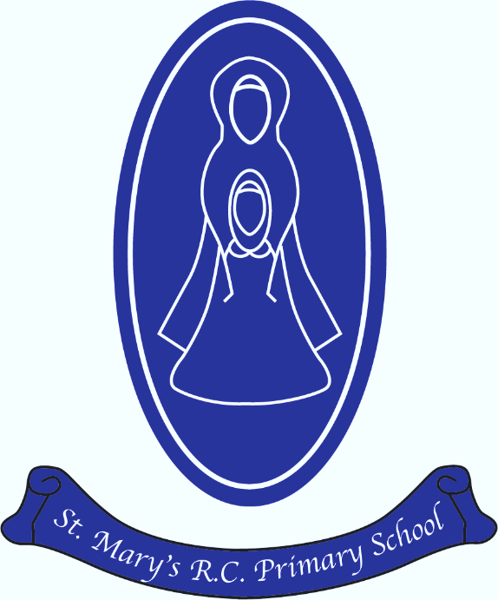
St Mary’s R.C Primary

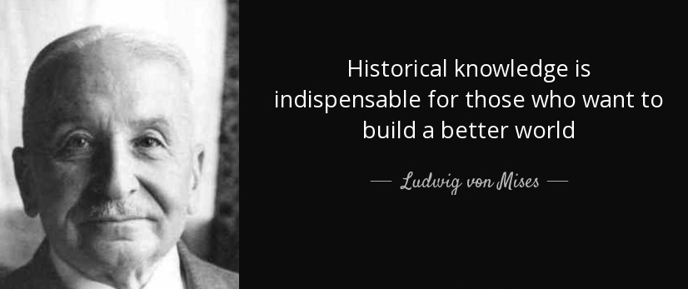
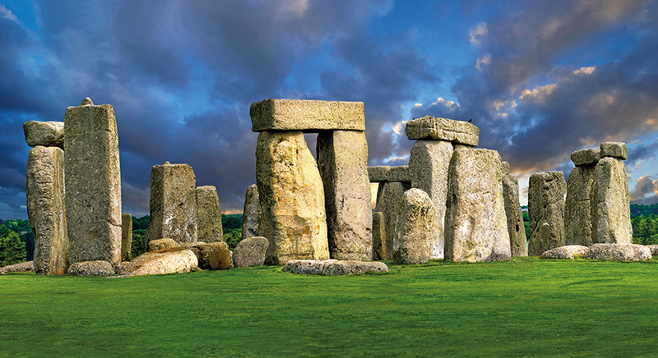
History Annual Curriculum Map
St Mary’s R.C. Primary
History Annual Curriculum Map

History Curriculum Map – Autumn Term
Term | Nursery | Reception | Year 1 | Year 2 | Year 3 | Year 4 | Year 5 | Year 6
Autumn 1 | Change in living memory | Chronology & generations | Rosa Parks | The Great Fire of London | Stone Age | Roman Britain | Anglo Saxons | Victorians
Autumn 2 |  | Significant event- local link
History Curriculum Map - Spring Term
Spring 1 | Use sources to find  out about the past | Change beyond  living memory/sources of evidence | Space |  | Bronze Age  Iron Age | Ancient Greece | Vikings | WW1  +WW2
Spring 2 | Change beyond  living memory/event
History Curriculum Map - Summer Term
Summer 1 | Change beyond  living memory/  person | Change beyond  living memory/  Victorian Seaside | Steam Engines | Grace Darling  Kings and Queens | Ancient Egypt | Ancient Maya | Tudors
Summer 2 | Change beyond  living memory/  evidence

