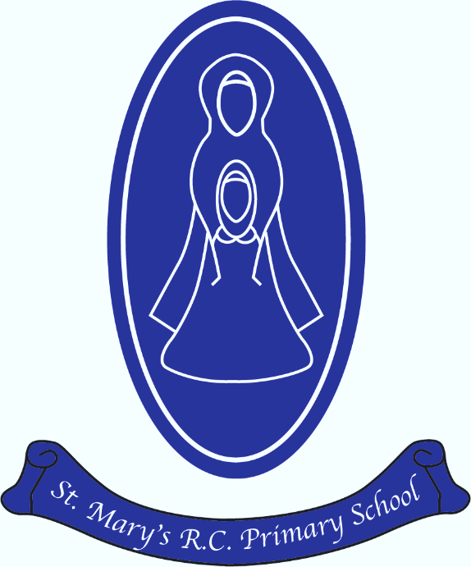
St Mary’s R.C. Primary

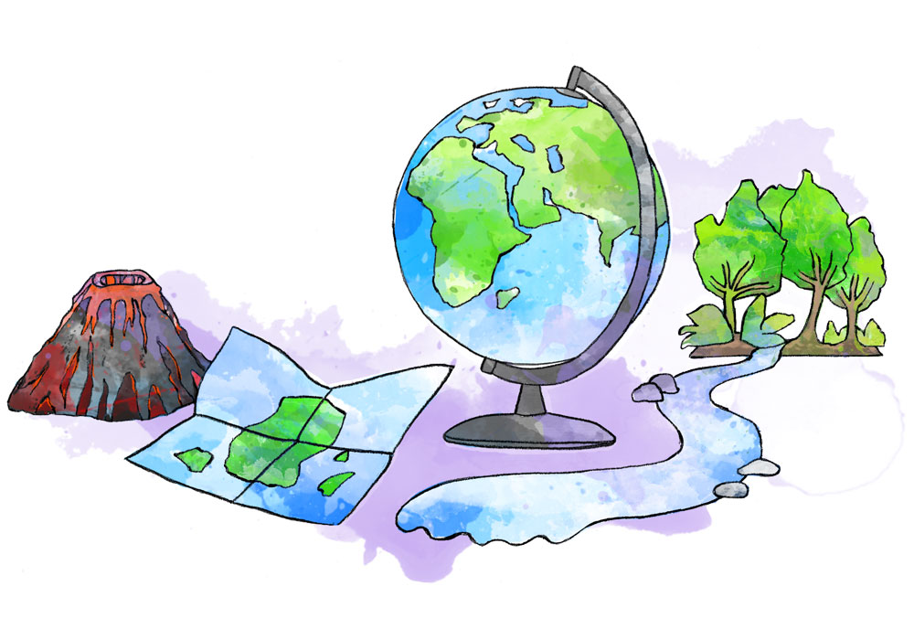
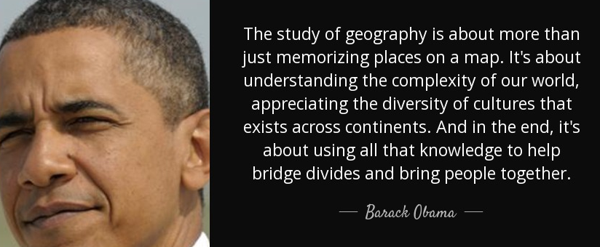
Geography Annual Curriculum Map
St Mary’s R.C. Primary
Geography Annual Curriculum Map

Geography Curriculum Map – Autumn Term
Term | Nursery | Reception | Year 1 | Year 2 | Year 3 | Year 4 | Year 5 | Year 6
Autumn 1 | Location  +  Environment | Human and Physical features  of the local environment Map Skills | Local Area | Our World | Spain  (inc exportation of natural resources-food) | Local Area-The Irwell Sculpture Trail | Britain Mapping | South America  (inc exportation of natural resources)
Autumn 2 | Weather  +  Seasons | Weather & Climate  +  Seasons
Geography Curriculum Map - Spring Term
Spring 1 | Contrasting Countries |  | Hot and Cold Places | Radcliffe | Mapping-The Journey | India  (inc exportation of natural resources-food) | Rivers
Spring 2
Geography Curriculum Map - Summer Term
Summer 1 | Location & Map Skills | Contrasting Countries  Map Skills | Rainforests | Africa | Extreme Earth | Renewable Energy | Australia-(inc exportation of natural resources-minerals) | Our Town  London
Summer 2 | Houses | Fieldwork

