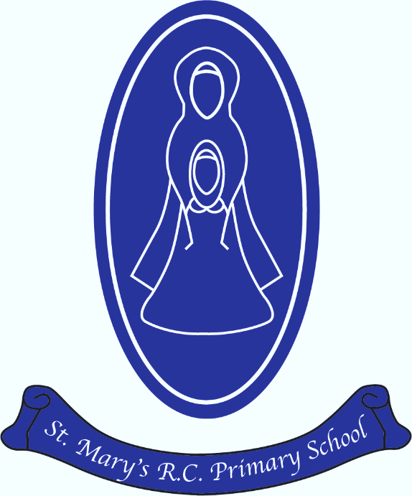
St Mary’s R.C Primary

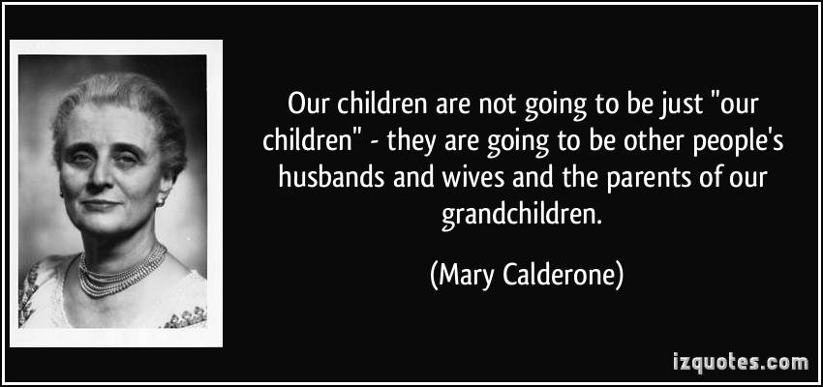
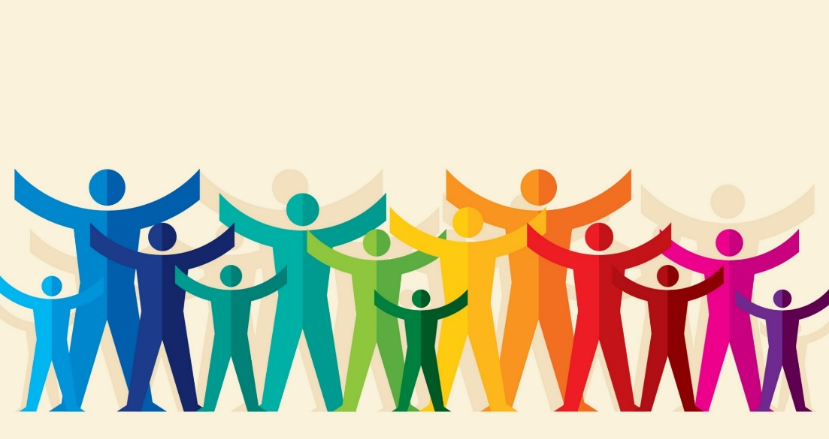
Relationships Health Education and End Points Curriculum Map
Module | Unit | EYFS | Key Stage 1 | Lower Key Stage 2 | Upper Key Stage 2
Created and loved by God | Religious understanding | To know we are created differently by God and that we are special | To know that God has created us to love and serve him.  To know who we are matters and what we do matters. | To know every life is precious from conception to death.  To know how to grow in our relationship with God.  To know that by regularly receiving the sacrament of reconciliation we grow in good deeds. | To know God has created us and wants us to put our faith in him.  To know becoming an adult is a phase of life.
 | Me, My Body and My Health | To know we all have different gifts and talents.  To know the correct names for the different parts of our body.  To know we need to look after our bodies. | To know that girls and boys have been created by God to be both similar and different.  To know what constitutes a healthy lifestyle.  To know how to maintain personal hygiene. | To learn about self-confidence.  To learn about respecting their bodies as a gift from God.  Learn about puberty.  Learn correct names and changes in their bodies. | To understand we can use our similarities and differences together.  To learn about the changes is girls and boys bodies.  How to make good choices that impact our health.
 | Emotional Wellbeing | To understand different likes and dislikes.  To understand emotions.  To know life stages from birth to death. | To know language to describe our feelings.  To understand the difference between feelings and actions.  To know choices have consequences. | To learn how emotions change as we grow.  To look at images in the media and misrepresentation.  To learn about wrong and risky behaviour.  To learn about how they were made. | To look at body image in relation to the media and thankfulness.  To understand the range and intensity of feelings.  To recognise harmful and harmless content online.  How a baby grows and develops in it’s mother’s womb.
Created to love others (this topic covers child on child abuse) | Religious Understanding | To understand we are part of God’s family. | To know Jesus cared for others and his expectations of them.  To know we should love other people the same way God loves. | To learn about Jesus as a friend. | To know God calls us to love others.  To know how we can participate in God’s love.
 | Personal Relationships | To learn how their behaviour affects others.  To understand the characteristics of positive and negative behaviours.  To recognise that if we have been unkind we should say sorry. | To know different types of bullying and how teasing is never acceptable.  The characteristics of positive and negative behaviour.  To know we should forgive and say sorry. | How to maintain good and healthy relationships.  To know the different types of relationships.  Develop a greater awareness of bullying (and cyber-bullying) and how to respond to this. | To understand pressure and where it comes from.  What does bodily autonomy mean?  Apply learning on thoughts and feelings to friendships.
 | Keeping Safe | To learn about safe and unsafe situations.  To know who to ask for help.  To learn about medicines. | To learn about saf and unsafe situations (including online)  To know they are entitiled to body privacy.  To know alcohol and tobacco are harmful substances.  To know when they should call 999. | To look at:  - Sharing online  - Chatting online  - How to stay safe in my own body  - Drugs, alcohol and tobacco  - First aid heroes | To look at:  - Sharing online  - Cyberbullying  - Types of abuse  - Impacts on lifestyle (negative and positive)  - Making good choices  - Giving assistance
Created to live in community | Religious understanding | To know God is love.  To understand community. | To know being made in God’s image means being called to love others.  To know what a community is. | To know God’s love as the trinity.  To know the human family. | Children will know God is a trinity.  Children develop a deeper knowledge of Catholic social teaching.
 | Living in the wider world. | To know what groups they belong to.  To understand their roles and responsibilities. | To know how to help at home.  That we have a duty of care to others and the world we live in. | To know God wants us to love and care for others.  To devise practical ways of caring for others. | Pupils will learn how to apply the principles of Catholic social teaching to current issues.

